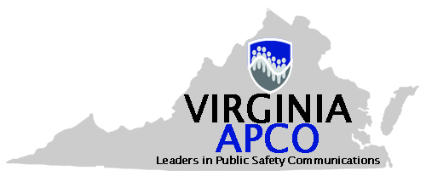

Public Safety Communications Awards Program

Nomination Package for 2024 Awards

The deadline for all nominations is March 14, 2025

VIRGINIA APCO PUBLIC-SAFETY COMMUNICATIONS INDIVIDUAL PERFORMANCE IN A CRITICAL INCIDENT AWARD

Instructions

Eligibility
This award is designed to honor an individual from a public-safety communications agency in the Commonwealth of Virginia who performed in an outstanding manner during a critical incident.
Nominees must have been employed by a public safety agency in the Commonwealth of Virginia or retired within the last 12 months. Nominees do not have to be members of APCO.
Nominations will be accepted by any supervisor within the chain of command or any group of three or more co-workers in agreement. Nominations must be received no later than 2359 hours on March 14, 2025.

Sample Job Titles:

Nominees may hold any title within a Public-Safety Communications Center.

Completing this form
- Save a copy of the downloaded version of this document to your computer’s hard drive. Nominations will only be accepted using this form.
- Type the required information directly into the saved version of the document.
- Be sure to include information for all requested sections.
- Include specific facts or examples wherever possible to back up your comments.
- Ask someone to proof the form before you submit it: Are there grammatical errors? Is there information that is unclear? Do the descriptions provide enough detail to “paint a picture” of the performance and contribution of the nominee to public-safety communications?

Submitting your nomination
Email the completed Microsoft Word nomination form as an attachment to jlee@vbgov.com. You will receive emailed confirmation that your nomination was received within three business days.
If you are unable to email the nomination, you can mail it to Jada Lee, VA-APCO Awards Committee,
Director, Virginia Beach 9-1-1 Emergency Communications, 2508 Princess Anne Rd, Virginia Beach, VA 23456-2506. All nominations must be received by 2359 hours on March 14, 2025.

Award Nominee Information
Name:
Agency:
Job Title:
Agency Address:
Address line 1:

Address line 2 (if applicable):

City:

State:

Zip code:
Agency Phone Number (including area code): | Agency Fax Number (including area code):
Email address:
Nominator Information
Name:

Agency:
Job Title:
Agency Address:
Address line 1:

Address line 2 (if applicable):

City:

State:

Zip code:
Agency Phone Number (including area code): | Agency Fax Number (including area code):
Email address: | How did you learn of the award?  __APCO web site  __Email from APCO  ___Postcard from APCO  ___Link from APCO’s MySpace page  ___Link from NPSTW page  ___Link from APCO’s conference page  ___Through a colleague  ___Through an APCO chapter  Other (please explain):

The Criteria

- Describe the nominee’s public safety communications agency. Please include staffing levels, size, and discipline (law, fire, EMS, PSAP only, etc.).

- Provide the nominees job title and list a brief explanation of their duties and responsibilities.

- Tell us how long the nominee has been at this job and any previous public safety communications positions held.

- Provide a brief overview of the incident that the nominee was involved in.

- Describe the actions of the nominee in handling the incident, including how their knowledge, professionalism and customer service skills helped to determine the outcome. List how those efforts were above and beyond the normal day to day work, and how creativeness, initiative and ability to think outside the box impacted the outcome of the incident.

- What sets this incident or event apart from all others, to warrant the recognition of the Virginia APCO Individual Performance in a Critical Incident Award?

